A STUDY OF HOTEL PRICING STRATEGY

**1. Reading the raw data of all cities in hotels dataframe.**

E:\Important Documents\Internships\IIM Lucknow\Week 4\Day 5\Output Photos\01READING.JPG

**2. Summary of the aforementioned dataframe.**

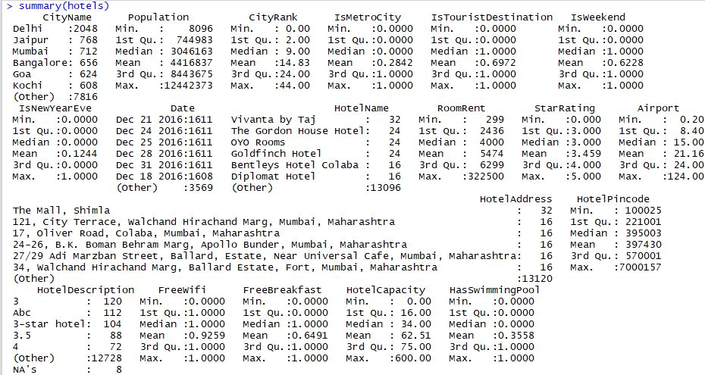

**3. Tables of Categorical variables**

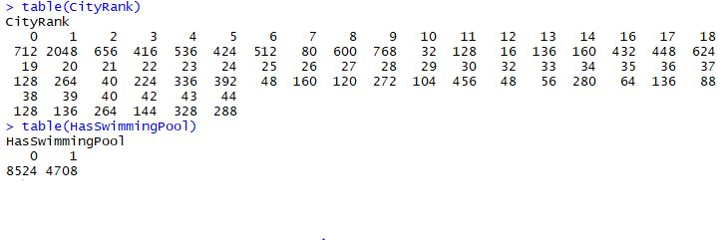

**4.1 Boxplot of StarRatings of different hotels**

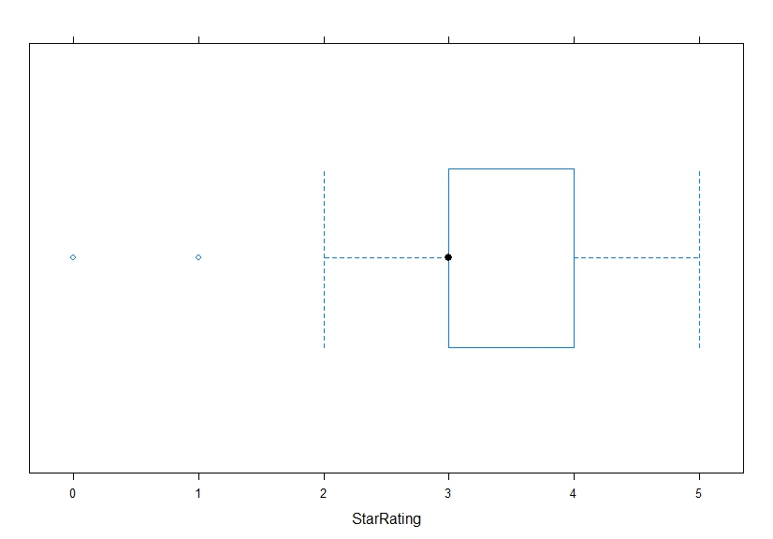

**4.2 Boxplot of Room Rent(Cheapest Double Occupancy) of different hotels**

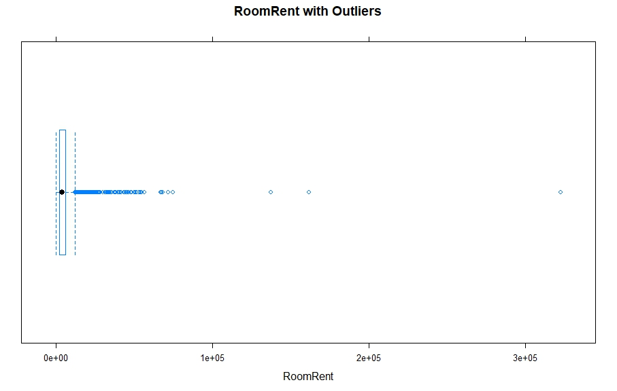

**4.3 Boxplot of Room Rent(Cheapest Double Occupancy) of different hotels(excluding outliers)**

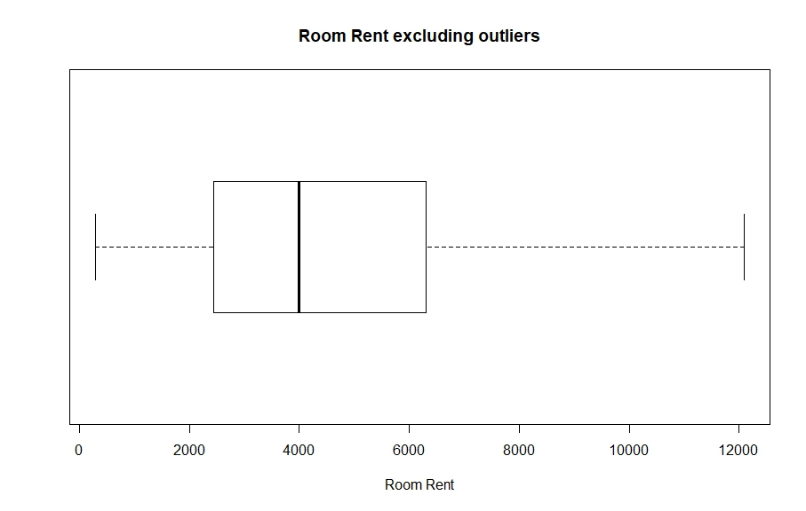

**5.1 Side by side boxplot of all cities (City Rank wise) and room rents of hotels in those cities**

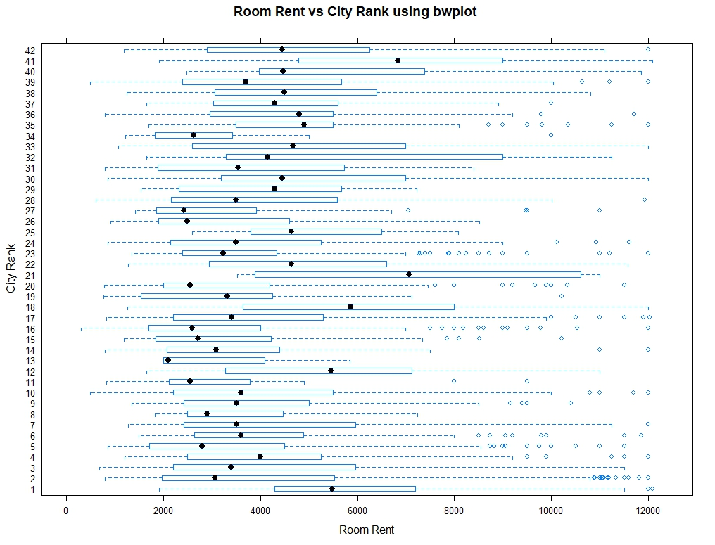

**5.2 Boxplot of Room Rent(Cheapest Double Occupancy) of different hotels with or without a swimming pool**

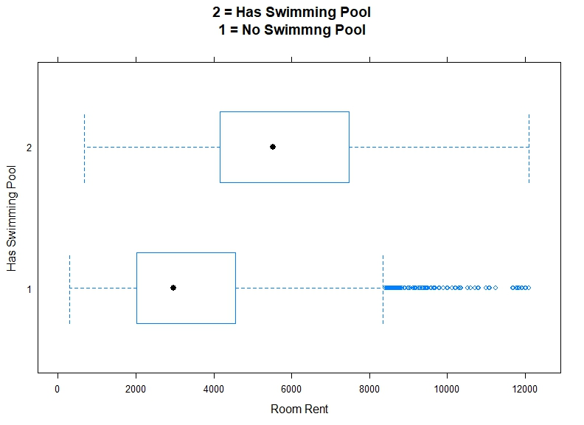

**5.3 Scatterplot of City Rank (Population wise) and Room Rent**

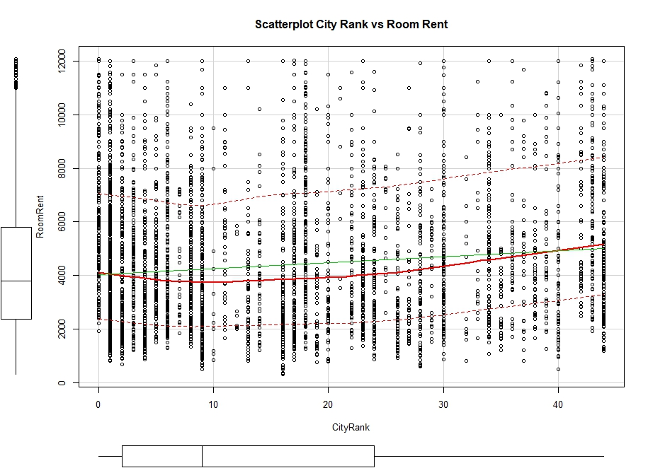

**6.1 Corrogram of Room rent with three other variables.**

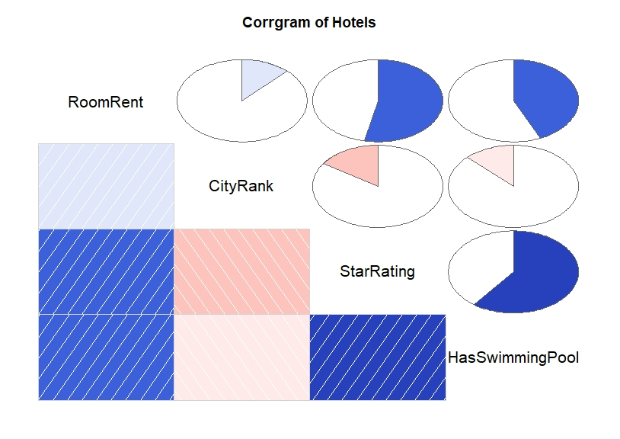

**6.2 Variance-Covariance matrix of the above four varibales**

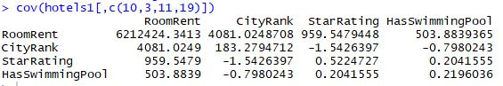

**7.1 Hypothesis 1: *The prices of hotel rooms at hotels with a swimming pool are higher than the prices at hotels without one.***

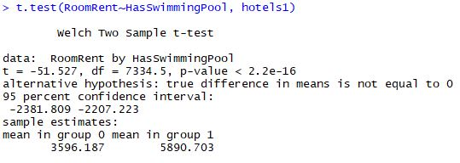

* The p-value is less than 0.05, hence RoomRent and HasSwimmingPool are not dependent on each other.
* We can reject the null hypothesis.
* There is high probability of RoomRent depending on availability of swimming pool.

**7.2 Hypothesis 2: *The prices of hotel rooms at hotels is higher on a weekend than on a regular weekday.***

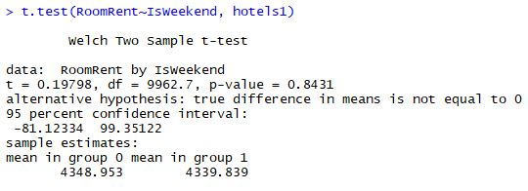

* Here, the p-value is greater than 0.05, which is larger than our confidence interval.
* We fail to reject the Null Hyopthesis, i.e. weekends and weekdays have equal Room Rents.

**8.1 Model 1: *The prices of hotel versus the presence of swimming pool.***

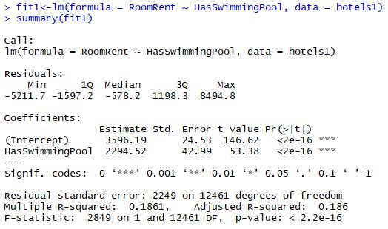

* The positive intercept and p<0.05 indicate a positive relation between the presence of swimming pool in a hotel and price.

**8.2 Model 2: *The prices of hotel versus whether the date of reservation is a weekend or not.***

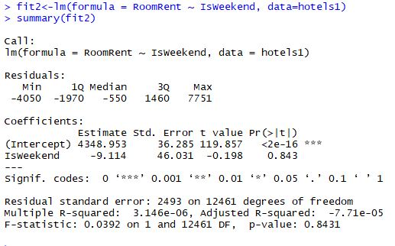

* The negative intercept and large p value denies any significant impact of weekend on the hotel price.

**8.3 Model 3: *The prices of hotel versus all the independent variables.***

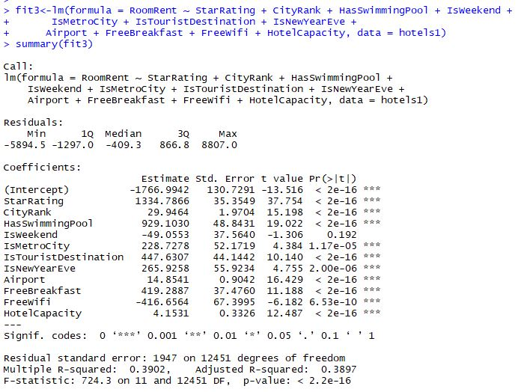

* The behaviour of HasSwimmingPool and IsWeekend doesn’t change in the presence of other variables which strengthens the t-tests results.